**INFORMATION TECHNOLOGY DEPARTMENT**

**AIRPORTS AUTHORITY OF INDIA**

(MINISTRY OF CIVIL AVIATION)

SAFDURJUNG AIRPORT, NEW DELHI-110000



**PROJECT REPORT ON**

**INVENTORY MANAGEMENT SYSTEM**

Report Submitted by:

Yamya Rastogi

BCA 2nd year

College : Maharaja Surajmal Institute

Report submitted under the guidance of:

Mr. V.K Sharma

Asst. General Manager

IT Department, Airports Authority of India

**DECLARATION**

I hereby declare that the project work entitled on **“INVENTORY MANAGEMENT SYSTEM”** is an authentic record of my own work carried out at **IT Department, Airports Authority of India** as a part of 2 week internship training for the industrial experience of BCA (Bachelors in computer applications) under the guidance of **Mr. V.K Sharma, Assistant General Manager, IT department, Airports Authority of India** during the time period 24th December 2017 – 7th January 2017.

Name: Yamya Rastogi

Date: 5th January 2017

**ACKNOWLEDGEMENT**

I am grateful to the authorities of **IT Department, Airports Authority of India** for having permitted me to go ahead with the project on **“INVENTORY MANAGEMENT SYSTEM”** for industrial experience on C++ programming language and other fundamentals used in IT.

I am particularly thankful to **Mr. V.K Sharma, Asst. General Manager (IT Department)** for his valuable guidance and advice during the course of this project.

I am deeply indebted to **Mrs. Sushma Singh**. Without her wise counsel and constant guidance, it would have been difficult for me to complete this project. Finally, I express my indebtedness to all who have directly or indirectly contributed to the successful completion of my internship.

**INDEX**

Organisation Profile.........................................................................5

IT Department, AAI..........................................................................7

Abstract............................................................................................9

1. Introduction................................................................................10

1.1Purpose.....................................................................................10

1.2 Scope........................................................................................10

1.3 Definitions, Acronyms and Abbreviations................................11

2. Overall description......................................................................12

2.1 Product perspective................................................................12

2.2 Product functions....................................................................12

2.3 User characteristics.................................................................12

3. Specific requirements.................................................................13

3.1 Usability...................................................................................13

3.2 Reliability.................................................................................13

3.3 Availability...............................................................................13

3.4 Response time.........................................................................13

3.5 Capacity...................................................................................13

3.6 Software support.....................................................................13

Data members and member functions...........................................14

Conclusion.........................................................................................

**ORAGANIZATION PROFILE**

**AIRPORTS AUTHORITY OF INDIA**

* Airports Authority of India is an organisation working under the ministry of Civil Aviation.
* It came to existence on 1st April 1995.
* It manages a total of 125 Airports, including 18 International Airports, 7 Customs Airports, 78 Domestic Airports and 26 civil enclaves at military airfields.



The Airports Authority of India (AAI) under the Ministry of Civil Aviation is responsible for creating, upgrading, maintaining and managing civil aviation infrastructure in India. It provides Air traffic management (ATM) services over Indian airspace and adjoining oceanic areas. It also manages a total of 125 Airports.

AAI also covers all major air routes over Indian landmass via 29 Radar installations at 11 locations along with 89VOR/DVOR installations collocated with Distance Management Equipment (DME). 52 runways are provided with Instrument landing system (ILS) installations with night landing facilities most of these airports and automatic message switching system at 15 airports.

AAI’s implementation of Automatic Dependence Surveillance System (ADSS) using indigenous technology, at Kolkata and Chennai air traffic control centres, made India the first country to use this technology in the South East Asian region thus enabling Air Traffic Control over oceanic areas using satellite mode of communication. Performance Based Navigation (PNB) procedures have already been implemented at Mumbai, Delhi and Ahmedabad Airports and are likely to be implemented at other Airports in a phased manner. AAI is implementing the GAGAN project in technological collaboration with the Indian Space Research Organization (ISRO), where the satellite based system will be used for navigation. The navigation signals thus received from the GPS will be augmented to achieve the navigational requirement of aircraft. First phase of technology demonstration system was completed in February 2008.

AAI has four training establishments viz. the Civil Aviation Training College (CATC) at Allahabad, National Institute of Aviation Management and Research (NIAMAR) at Delhi and Fire Training Centres (FTC) at Delhi and Kolkata. An Aerodrome Visual simulator (AVS) has been provided at CATC and non-radar procedural ATC simulator equipment is being supplied to CATC Allahabad and Hyderabad Airport. AAI has a dedicated Flight Inspection Unit (FIU) with a fleet of three aircrafts fitted with flight inspection system to inspect Instrument Landing System up to Cat – 3, VORs, DMEs, NDBs, VGSI (PAPI, VASI) and RADAR (ASR/MSSR). In addition to in-house flight calibration of its navigational aids, AAI undertakes flight calibration of navigational aids for the Indian Air Force, Indian Navy, Indian Coast Guard and other private airfields in the country.

**INFORMATION TECHNOLOGY DEPARTMENT,AIRPORTS AUTHORITY OF INDIA**

SAFDARJUNG AIRPORT, NEW DELHI – 110054

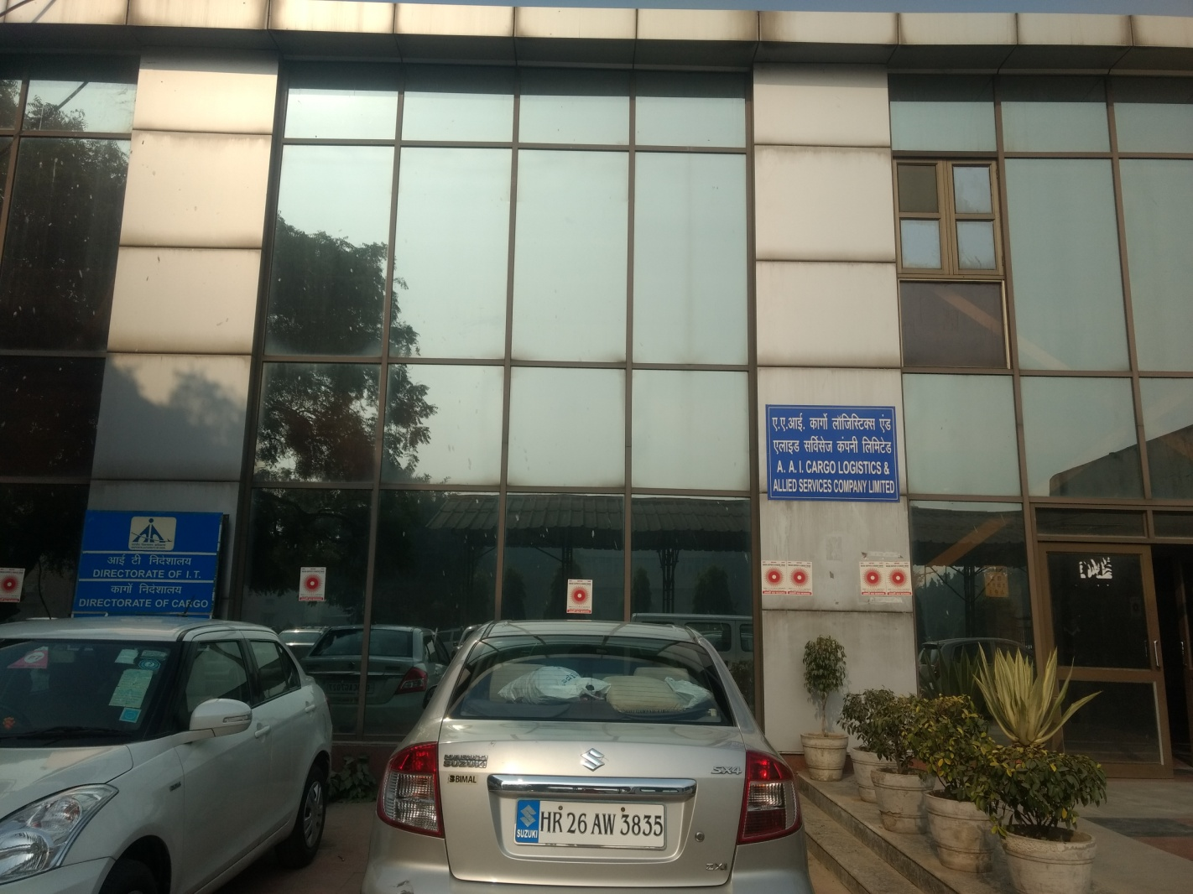

The IT Department of the Airports Authority of India performs many important functions. These include:-

* Development and hosting of AAI website and Website Management. Use of Web based Information Technology as a strategic business tool to improve the business process and efficiency of the Organization.
* Maintenance & Provision of Internet / Intranet services to all the executives and sections of AAI on need basis as an enterprise service using high end leased line.
* Provision of corporate e-mail services to all the employees of AAI as a means of professional communication mechanism.
* Ensuring the availability of all critical applications for AAI officials and general public on intranet or internet.
* Procurement, implementation, integration & standardization of IT systems.
* Integration of all existing and upcoming systems with AAI Intranet.
* Planning, development & commissioning of Centralized Softwares and other applications like AAI Website, OPMS, GLAMS, NOCAS, ERP, e-TaPS using Centralized Database Servers & Web Enabled Application Software.
* Assessment and planning of IT related Training and in-house application development.
* Planning and implementation of suitable Information Security Management System (ISMS) to ensure safety, security and availability of Information to authorized persons only.
* Implementation& operation of ERP System in Finance, HR, Material Management and project system.
* Implementation of e-tendering and Procurement System (e-TAPS) for bringing transparency to the process.

**ABSTRACT**

**Inventory Management system** deals with the tracking of the Asset for maintaining the technical stock of the IT inventory. It maintains the details of the employees who are allotted with any asset. The Administrator will be able to maintain the Asset status on a regular basis.

The Administrator will be responsible to make the record of each asset for its allotment and service. Thus management of Assets in the department can be done automatically after records are available.

An Inventory Management System helps the organization stay organized, avoid costly errors and also track all the inventory activity.

**1. Introduction**

This Inventory Management System is developed using C++ programming language. It is a single user application developed for Airports Authority of India (AAI), a national organization devoted in all round development of Civil Aviation Infrastructure of India.

This project is aimed at developing an application for providing an inventory management system. This system is an application that can be used by a single user to maintain all the inventory records of the department. The user can enter the entire available assets into the inventory, delete assets as well as add issue records when an asset is issued to an employee. The user can also view all the items that are currently available in the inventory. The program is developed in such a manner that it is easily manageable, time saving, easy to use and relieving one from manual works.

**1.1 Purpose**

To overcome the drawbacks of the existing file system, the proposed system has been evolved. This project aims to reduce the paper work and save to manage all the assets in the inventory efficiently.

The advantages of this project are as follows:-

* Proper utilization of recourses – stock management
* Tracks the status of the assets
* Proper allocation of assets
* It provides an option to enter all the asset records
* It is reliable and produces approximate results

**1.2 Scope**

This project comes with many features that are meant to decrease the latency that arises while operating through the manual process. It also helps in arranging of all the assets in the inventory and also maintenance of information related to the assets.

The administrator can handle all the operational based information and procedures that take place while the system in functioning.

**1.3 Definitions, Acronyms and Abbreviations**

* AAI – Airports Authority of India, Safdarjung Airport,Delhi
* Provided wherever necessary in the report

**2. Overall Description**

**2.1 Product Perspective**

This C++ program is an application that can be accessed by a single user to manage all the asset details and to manage all the data records that are entered into the program as well as all the procedures that are carried out using the program. The program can provide all the asset details including product code, price of the product, total value of products, no. of products left in the inventory etc.

The program all takes all the employee details while issuing an asset to the employee including employee name, employee number, employee department etc.

**2.2 Product Functions**

The program maintains all the data of the assets using a unique product id. The assets are added, deleted and issued to the employees using this product identification number. All the product Ids are provided and show up when the program runs.

The inventory is updated in real time when an asset is issued to an employee or an asset is deleted from an inventory.

If the wrong product id is entered, the program will show an error.

**2.3 User characteristics**

The user of the system is the administrator who maintains the system. The admin is assumed to have basic knowledge of the computers and Internet browsing. The administrator of the system is expected to have more knowledge of the internals of the system and is able to rectify the small problems that may arise due to power failures or any other catastrophes to maintain the system.

**3. Specific Requirements**

**3.1 Usability**

* The program must be present in the system along with a C++ compiler in order for it to compile and run on the system.
* Since this is a very user friendly program, no specific training is required for a person to use this program
* This program is easy to use and self explanatory.

**3.2 Reliability**

The program is very reliable as all the information related to employees and assets can be stored in it in a very efficient manner.

**3.3 Availability**

The program is available to all the users and can be used 365 days a year. The program shall be operational 7 days a week, 24X7X365.

The program is developed in such a manner that it may not fail.

**3.4 Response Time**

The program shall take as less time as possible to provide service to the administrator.

**3.5 Capacity**

The system is capable of handling one user at a time.

**3.6 Software Support**

Programming language used: C++

Operating System: Windows

**Data Members and Member Functions used in the Program:-**

**Data members:-**

* int qty
* char name
* char fname
* char lname
* int empid
* char department
* int code
* int price

**Member functions:-**

* void add_
* void issue_
* void delete_
* void display_
* void initial
* void add_ - this function is used in the program to assets into the inventory. A list of item category along with item codes will be displayed when the program is compiled. The user will then input all the information that is asked (item code, item category, item price, item quantity etc) to add assets to the inventory.
* void issue_ - this function is used to issue assets to the employees as and when required. The function will ask for various inputs such as employee name, employee id, and employee department etc before issuing the assets. The assets in the inventory will be updated in real time after an asset has been issued.
* void delete_ - this function is used to delete assets from the inventory. This function can be used when some assets were added to the inventory by mistake or they got misplaced/ stolen etc.
* void display_ - this function is used to display the current status of the inventory. When some of the new assets are added to the inventory or are issued to an employee, this can function can be used to check the current status of the inventory and to check how many assets of each type are remaining.
* void initial – this function is used to initialize the value of an integer variable to 0. Every time an item is added to the inventory, the value of all the variables has to incremented by one. This is done using the variable that was initialized to 0. Its value is incremented every time.

**CONCLUSION**

The inventory management system developed on the C++ programming language runs and works successfully. It can be used by a single user at a time to deal to with all the inventory assets, their price, quantity etc as well as employee information such as name, id, department etc.

Programming has no limits and there can be a number of features that can be added to this program according to the requirements of the pgranisation.